Exercise 2: E-Commerce Platform Search Function
Why Asymptotic Notation Matters
In an e-commerce platform, customers search for products thousands of times every day. As the number of products increases, the search operation should remain fast and efficient.
Asymptotic notation helps developers measure the efficiency of algorithms and predict how they will perform when the amount of data grows.
Big O Notation
Big O notation represents the growth rate of an algorithm.
It helps us understand:
- How much time an algorithm takes to execute.
- How performance changes as the input size increases.
- Which algorithm is more efficient for large datasets.
Search Scenarios
Best Case
The desired product is found immediately.
Example:
The first element in the array matches the search key.
Average Case
The product is found somewhere in the middle of the array.
Worst Case
The product is found at the end of the array or does not exist.

Suitable Search Algorithms
Algorithm | Description | Time Complexity
Linear Search | Checks each product one by one | O(n)
Binary Search | Repeatedly divides sorted data into halves | O(log n)
Why Binary Search is Faster
Instead of checking every product, Binary Search eliminates half of the remaining products after each comparison.
For example:
1000 Products
Linear Search may check: 1000 products
Binary Search may check: Only about 10 products
This makes Binary Search much faster for large e-commerce platforms.
Implementation
Product.java
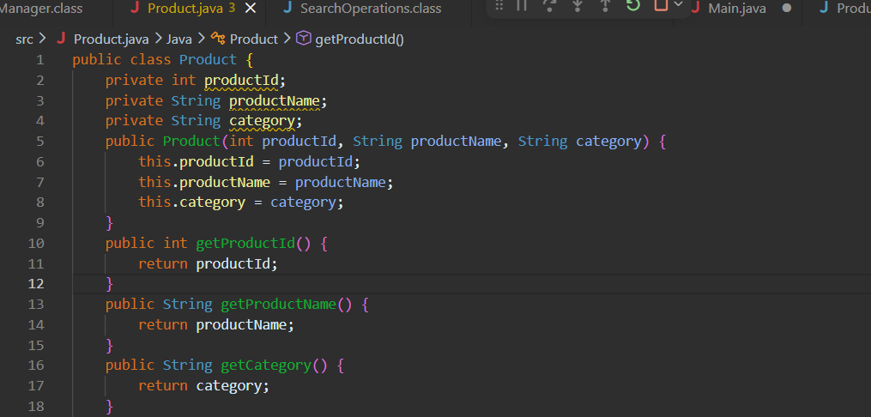

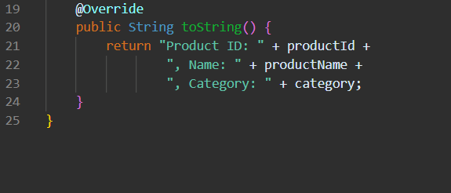
SearchOperations.java
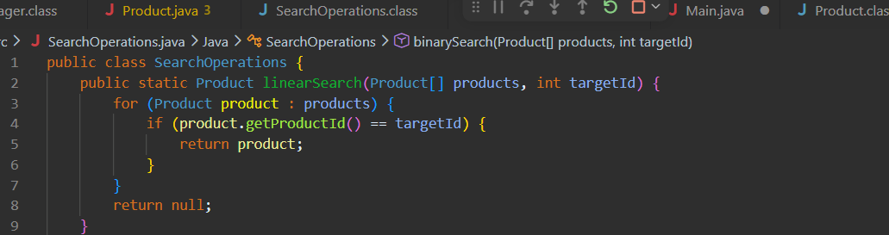

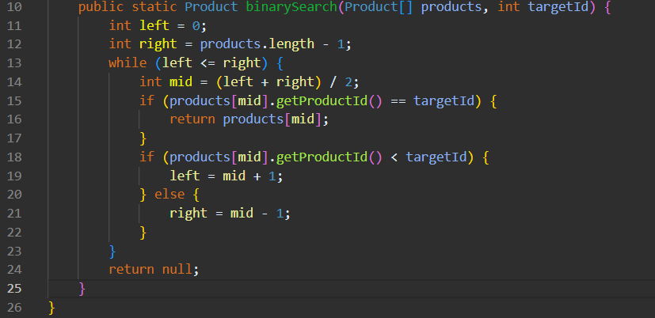

Main.java

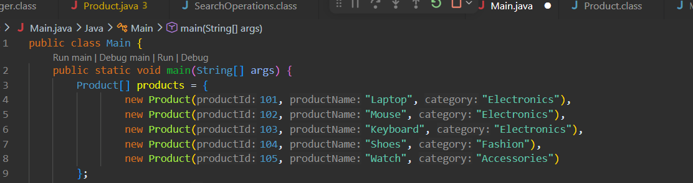

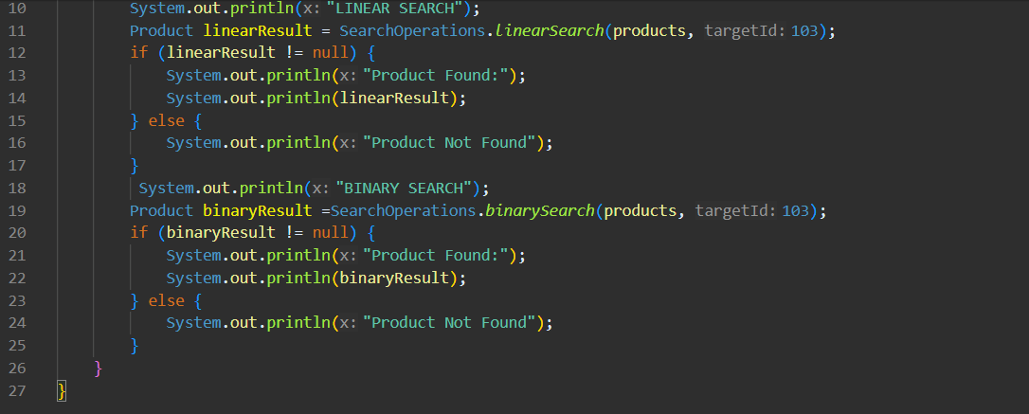

OUTPUT

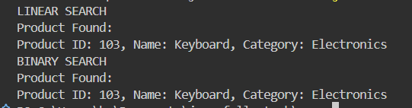

Time Complexity Analysis
Operation | Linear Search | Binary Search
Best Case | O(1) | O(1)
Average Case | O(n) | O(log n)
Worst Case | O(n) | O(log n)

Which Algorithm is Better and Why?
Binary Search is Better for an E-commerce Platform because:
- Binary Search is much faster than Linear Search for large datasets.
- It follows the divide-and-conquer approach by dividing the search space into two halves in each step.
- It requires fewer comparisons to find a product.
- It improves the overall search performance of the platform.
- It provides a better user experience by reducing search time.
- It is suitable for e-commerce websites that contain thousands or millions of products.
- Its average and worst-case time complexity is O(log n), which is more efficient than Linear Search.
- Once the product list is sorted, products can be found very quickly.
Limitations of Binary Search
- The data must be sorted before performing the search.
- Additional effort is required to maintain the sorted order when new products are added.
Why Linear Search is Less Suitable
- It checks products one by one.
- The number of comparisons increases as the number of products grows.
- It becomes slower for large inventories.
- Its average and worst-case time complexity is O(n).
Conclusion
- Linear Search is suitable for small datasets or unsorted data.
- Binary Search is suitable for large e-commerce platforms with sorted product data.
- Therefore, Binary Search is the preferred algorithm because it provides faster search results and better scalability.

